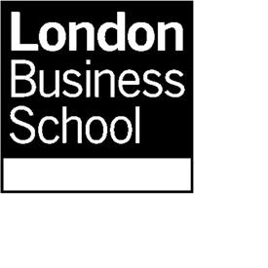
Masters in Finance (part-time) application

Essay questions

Name:

Instructions:

The essays are one of the most important parts of your application – this is your opportunity to “sell yourself”.

The Admissions Committee will consider carefully your answers to the following questions. Please complete all of the questions beginning your answer below each question in the box provided (which will resize as you type). Please include a word count for each reply.

Version date: 2017.07.21

- What is your motivation for applying to the LBS MiF? If career related, please outline your aims and strategy for achieving your career goals. (maximum 400 words)
Your word count:

- What specific areas of London Business School life are you most excited about getting involved in and where do you believe you will add value to the School Community? (maximum 300 words)

Your word count:

